1. So far
   1. We know how to build Config Server pointing to a **centralized repo like Github** having all configurations.
   2. What kinds of configurations we need to make inside in individual microservice so that they load based on current active profile.
   3. We also generated Docker images and pushed them onto Docker Hub.
2. **Jatin**: Unlike Dockerfile, docker-compose file can be put anywhere on your file system as it has nothing to do with your code base but images.
3. 
4. Let’s see the different docker compose files for different environment.  
   Graphical user interface, text, application

   Description automatically generatedLet’s go inside.  
   Graphical user interface

   Description automatically generated with low confidenceLet’s open dev folder  
   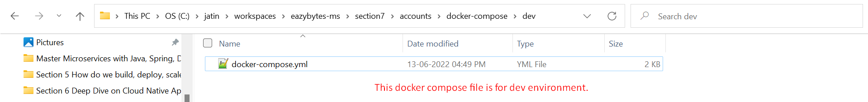Let’s open this file.  
   Graphical user interface, application

   Description automatically generated  
   Graphical user interface

   Description automatically generated with medium confidence